**“Covid 19 Analysis PowerBI”**

**Course Number**

**Student's Name**

**Instructor's Name**

**Introduction**

The COVID-19 Pandemic Analysis Dashboard has been meticulously designed to provide an insightful and interactive overview of the global impact of the COVID-19 pandemic. As the world grapples with the challenges posed by this unprecedented public health crisis, our dashboard emerges as a vital tool for understanding the dynamics of the virus’s spread, the efficacy of interventions, and the progress made in combating it.

Our primary data source for this dashboard is the COVID-19 Daily Cases dataset, a comprehensive compilation of global data detailing daily reported cases. This dataset includes critical metrics such as the number of confirmed cases, deaths, recoveries, and testing statistics. The coverage period of our analysis extends from the onset of the pandemic in early 2020, providing a detailed timeline of the virus's progression over time.

The objective of this dashboard is manifold. Primarily, it aims to offer a clear visualization of COVID-19 trends, facilitating a better understanding of its trajectory across different geographies and timeframes. Additionally, it seeks to provide valuable insights into the effectiveness of public health measures, the impact of the virus in various regions, and the progression of vaccination efforts globally. Our dashboard is designed not just for health professionals and policymakers but also for the general public, to offer an accessible platform for comprehending the vast and complex data surrounding the COVID-19 pandemic.

**Detailed Description of Each Section**

**Daily Case Trends**

Visualization Description - it uses line chart to show the daily trend date against the sum of deaths, recovery and the state.  
Also uses slicer to filter data according to state.

Lastly it uses the Card to display the number /total number of the affected rows in relation to the dataset.

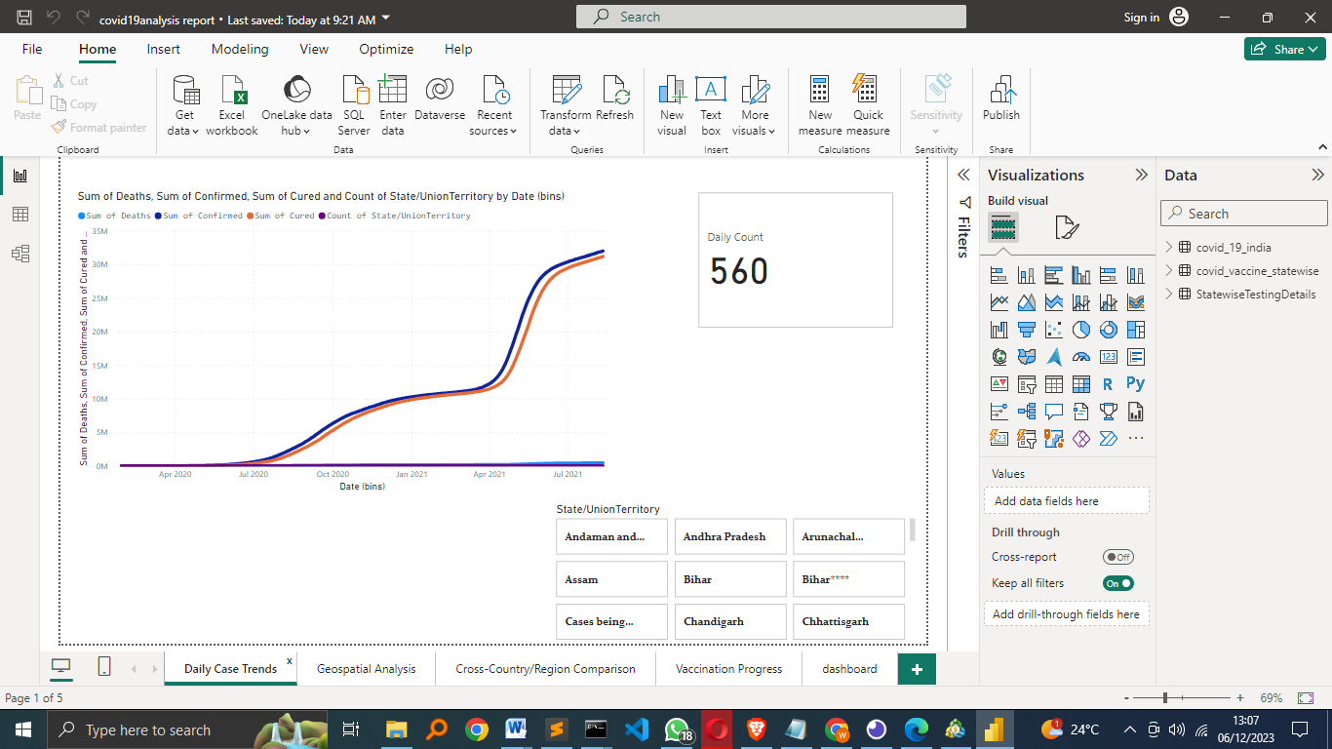

**Geospatial Analysis**

Map Details –

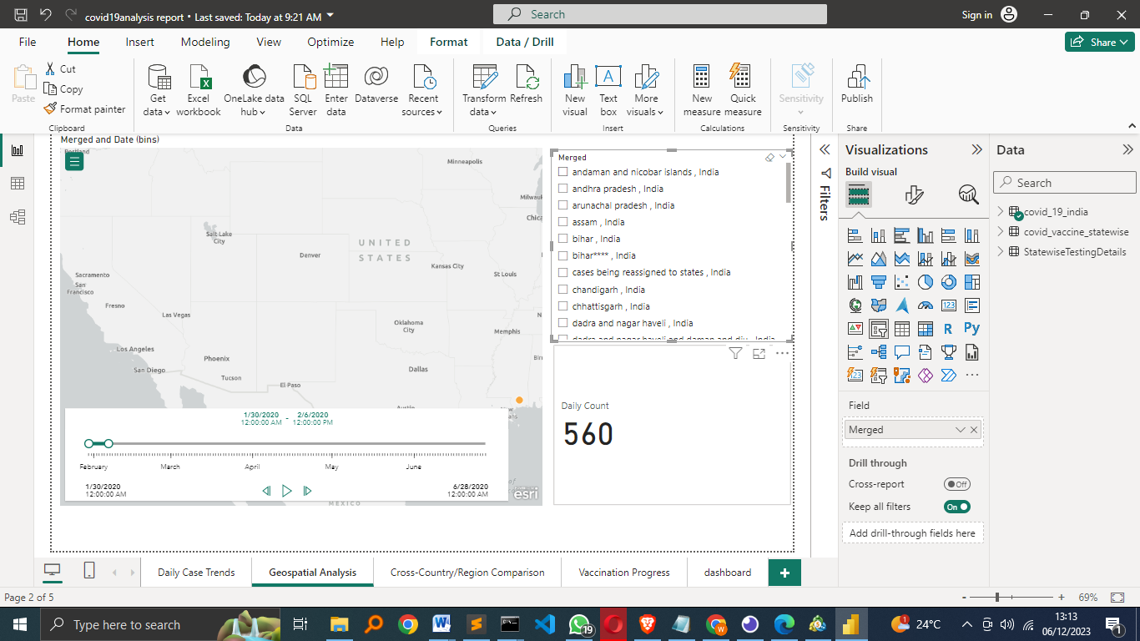

Uses the ArcGIS maps from power Bi to locate different states, added the slicer and the card for better visualization of the information.

**Cross-Country Comparison**

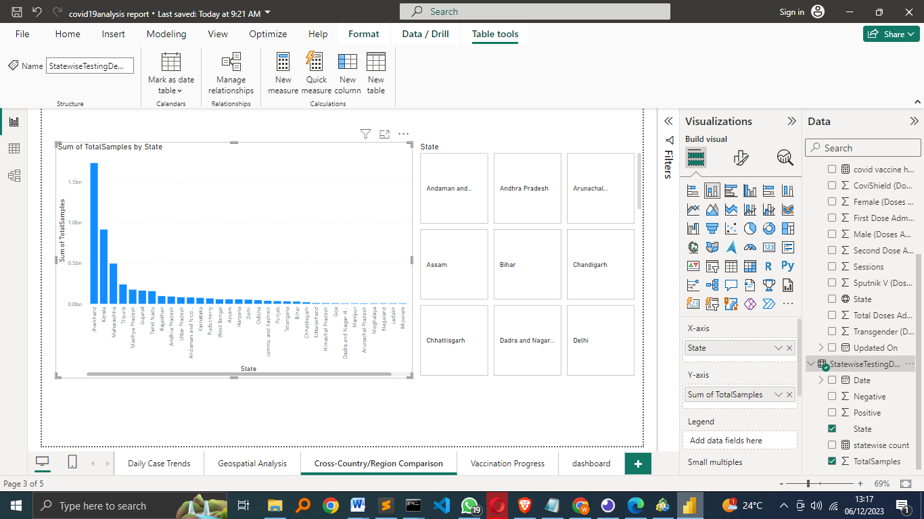

Used stacked charts to visualize the states against total sample taken.  
**Public Health Measures Impact**

Helps to determine which state has better /less positive people, this way a person can make better decisions and avoid getting covid.

**Vaccination Progress**

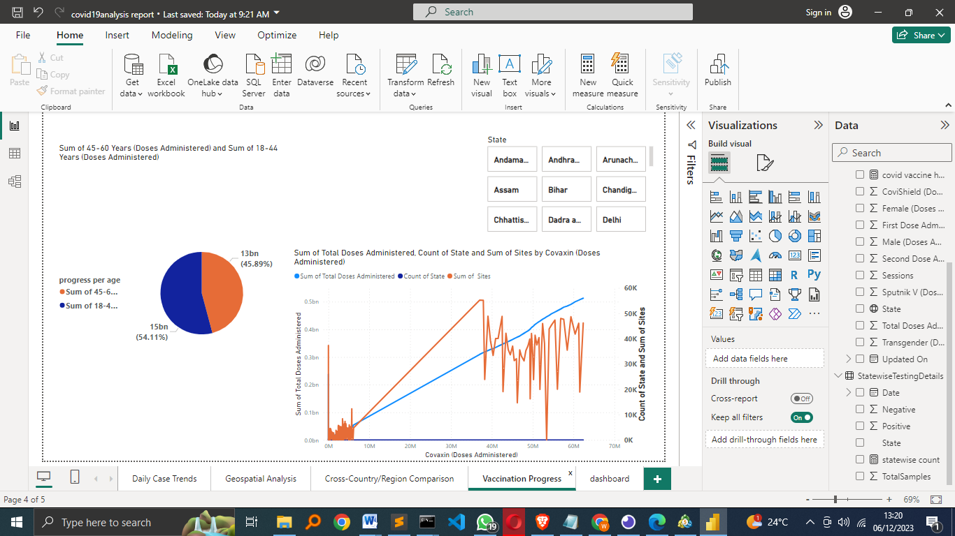

Used line chart to visualize the Sum of Total Doses Administered, Count of State and Sum of Sites against Covaxin (Doses Administered).

Used the pie chart to show Sum of 45-60 Years (Doses Administered) and Sum of 18-44 Years (Doses Administered) to see the correlation and determine which age group is actively taking the dosage.

**The Dashboard**

It shows the combination of all processes done above.  
Helps for faster navigations.

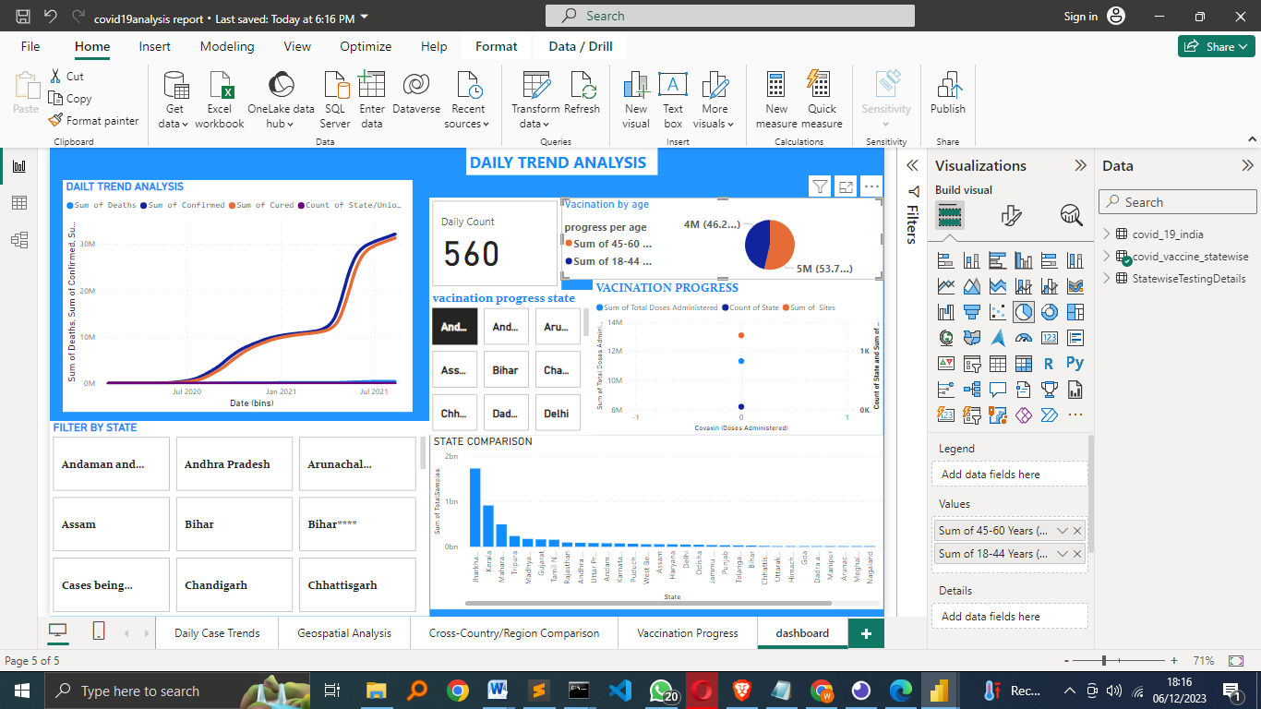

**Conclusion**

The COVID-19 Pandemic Analysis Dashboard serves as a critical analytical tool, offering profound insights into the course and impact of an unprecedented global health crisis. By synthesizing complex datasets into clear, interactive visualizations, this dashboard not only enhances our understanding of the pandemic's progression but also informs effective response strategies. It highlights key trends and patterns in infection rates, recovery, and mortality, thereby assisting policymakers, health professionals, and the public in making informed decisions. In essence, this dashboard is more than just a collection of data; it is a beacon of clarity in navigating the challenges posed by COVID-19, contributing significantly to our collective effort in combating and eventually overcoming this pandemic.